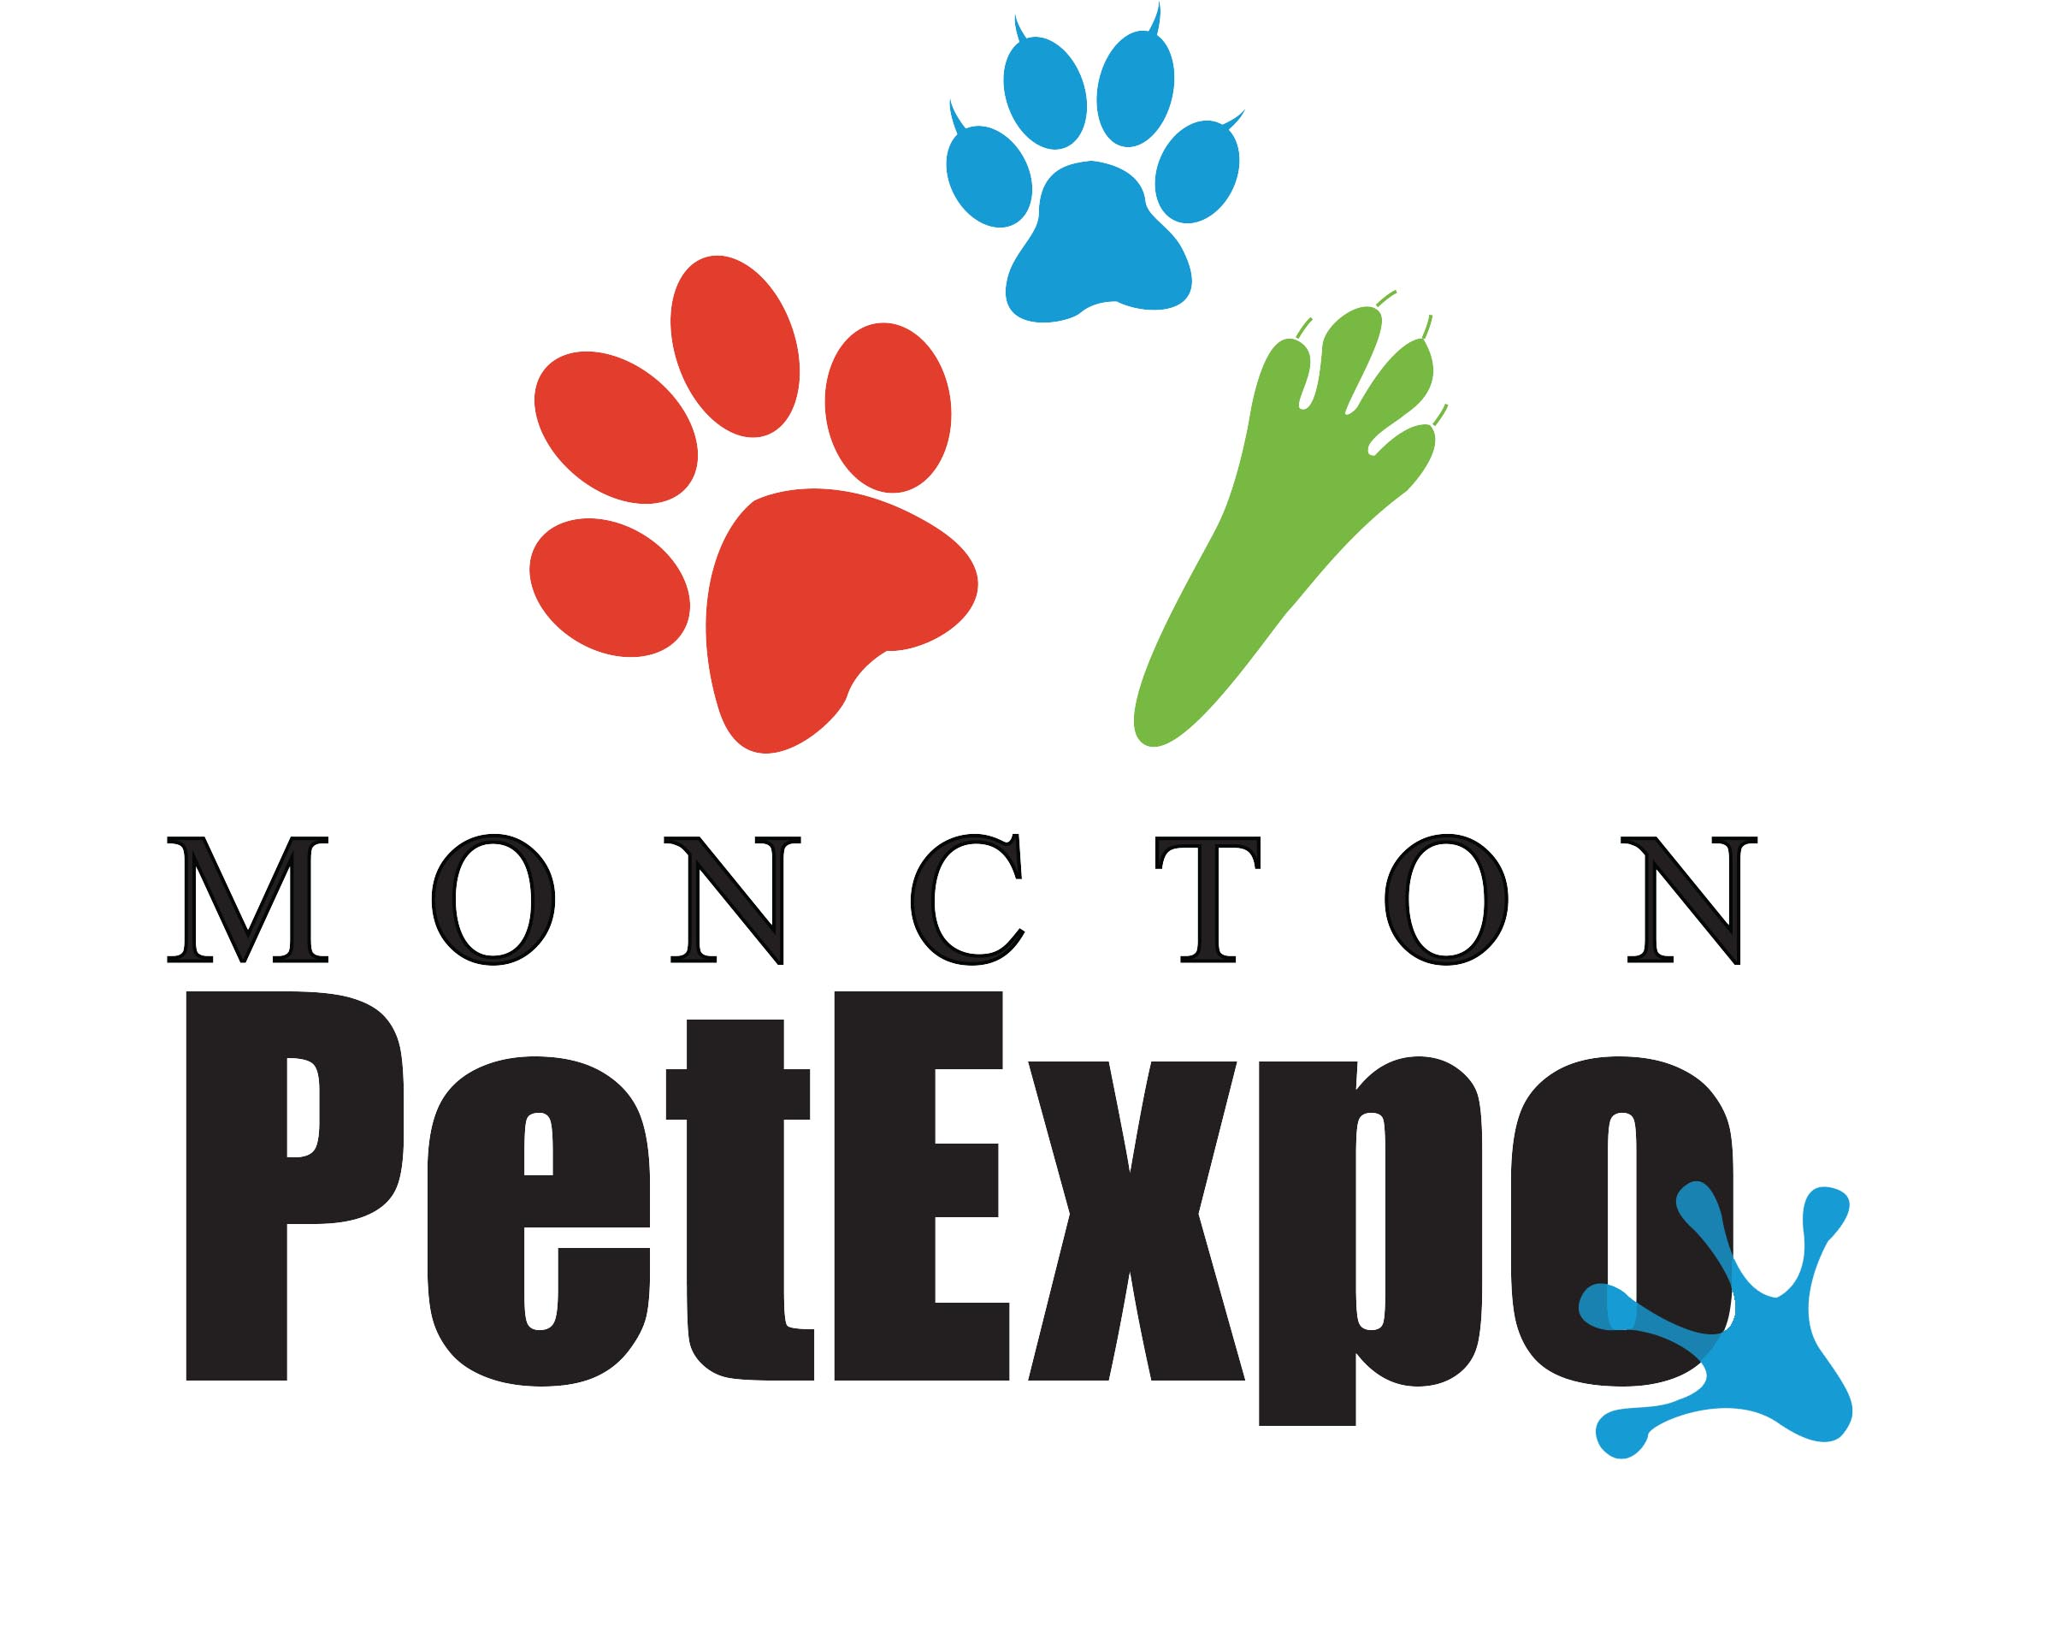
Dear Friends and Supporters,

This fall, on September 27th, the First Annual Moncton Pet Expo will be taking place at the Coverdale Centre in Riverview. The show will be a hit, drawing attendees from as far east as Halifax and as far west as Fredericton. Plenty of homegrown talent will be showcased in the live demonstrations portion of the agenda, meanwhile local exhibitors will be marketing themselves and their businesses at booths. It is going to be a great day for all who attend and all of the proceeds will be donated locally to charities who help animals in need.

The members of the Expo Organizing Committee endeavor to create a booklet complete with advertisements and coupons, which will be given to every person upon entry to the show. Your participation in this initiative will be directly correlated to the success of the show and is an excellent opportunity to get involved in the community, all the while increasing the reach of your business.

The cost for 1/8 of a page (double-sided), print–ready ad is a steal of a deal, coming to a total of $25.00, and as mentioned before, all proceeds will be donated to the beneficiaries we have chosen- The Abandoned Cat Rescue and the Greyhound Pets of Atlantic Canada.

Both of the above-mentioned organizations work very hard to make a difference and are full of dedicated volunteers, but as with all not-for-profits, could use as much help as they can get. Increase the goodwill of your business and lend a local hand. Get in touch with the Moncton Pet Expo Team today to reserve your spot in the brochure. Check us out on Facebook at https://www.facebook.com/monctonpetexpo, find us online at www.monctonpetexpo.weebly.com, or email us at moncton.pet.expo@gmail.com.

The deadline for accepting advertisements to be included in our printed materials is September 1st. Thank-you for your time and consideration. We look forward to hearing from some of you soon.

Sincerely,
The Moncton Pet Expo Team

